Birds Nest
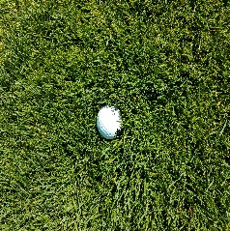
When you miss a green and your ball ends up in the rough you may find a variety of lies. The ball may sit up, be half way buried or be sitting in a “Birds Nest”. This term refers to a ball that is sitting down in the rough and is surrounded by grass (pictured below). The first two lies are fairly predictable. But when it comes to a ball that is buried deep in the grass, it is anyone’s guess how it will come out. Reading the lies is step one. Taking the proper approach is step two.

If you believe the grass between the back of the ball and club face will dramatically reduce spin then you need to change your approach. Off a tight lie, you should square in the stance, club face and make sure you swing down the target line. In a “Birds Nest” the spin rate will be dramatically reduced, resulting in a knuckle ball. There are two combinations to stop a ball:

- Spin and Trajectory
- Trajectory

Off a tight lie you want to make sure that the axis tilt, or direction of the backspin, is straight up and down. This will produce a ball that lands on the putting surface, checks and releases to the hole without any side spine.

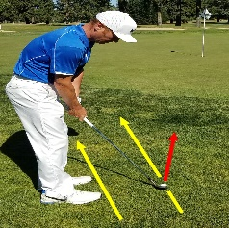
Out of the rough, you must rely on trajectory to stop the ball since spin will be non-existent. In order to hit the ball higher with less spin you need to adjust your set-up. First, open up your stance and club face (see below). Your weight and hands need to be leaning towards the target so you hit down on the ball and the leading edge of the club can cut through the grass. From here, this is the only time you will ever hear me to tell you to tighten your grip. You need to make
sure the grass does not snag the club.

When making the swing you need to focus on several keys. Make sure you swing parallel to your toe line (cutting across the line). You need to keep your lower body quiet and keep the face open on the follow through. This is very similar to a bunker shot. The ball will come out high and soft with minimal spin resulting in a shot that lands with minimal roll.

With help getting out of a “Birds Nest” or any other areas of your game, please visit www.brianflugstad.com to book your next lesson!

